**Testing**

**1) Client-side:**

When the user launch the application, he/she would see the “Report” button and click on it (as shown in figure 1), the application would get into the second activity (as shown in figure 2). In the second activity, victims can add information of a hazard and submit this report to the responder.

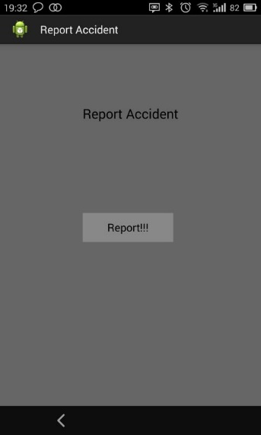 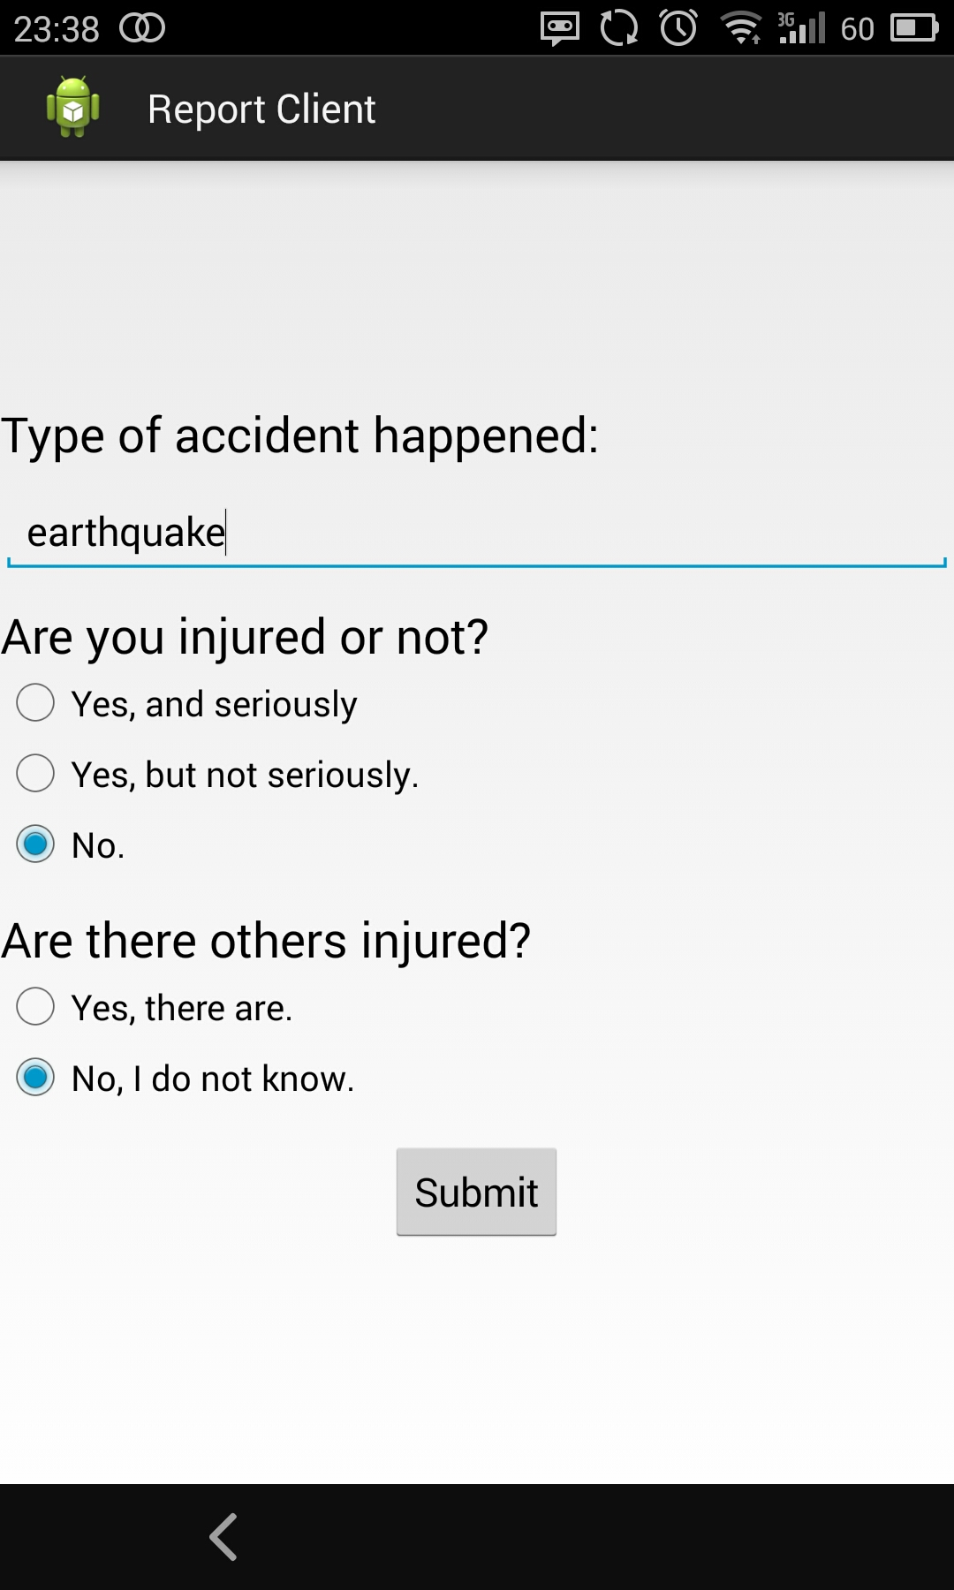

Figure 1 Client-side 1st activity Figure 2 Client-side 2nd activity

After filling in the information and click on the “Submit” button, there would be a dialogue saying that “Do you want to send this report now?”, if YES, the application would go into the third activity; if CANCEL, the application would stay on previous activity, as shown in figure 3.

In the third activity, the user can see his/her location using Phase1. And there is also a checkbox for user to submit whether he/she is picked up by a responder or not. If he/she is picked up by a responder, he/she can check the checkbox, and then the application would send his/her last information and tell the responder he/she is picked up. And the application would automatically turn into the second activity, as shown in figure 4.

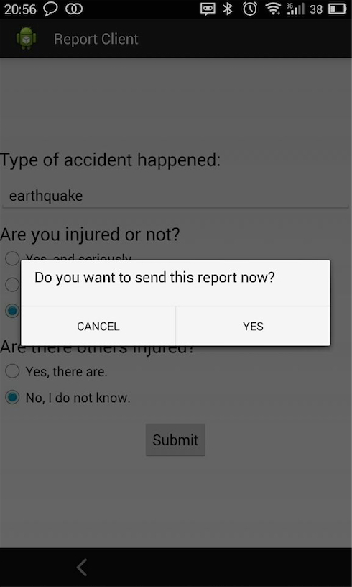 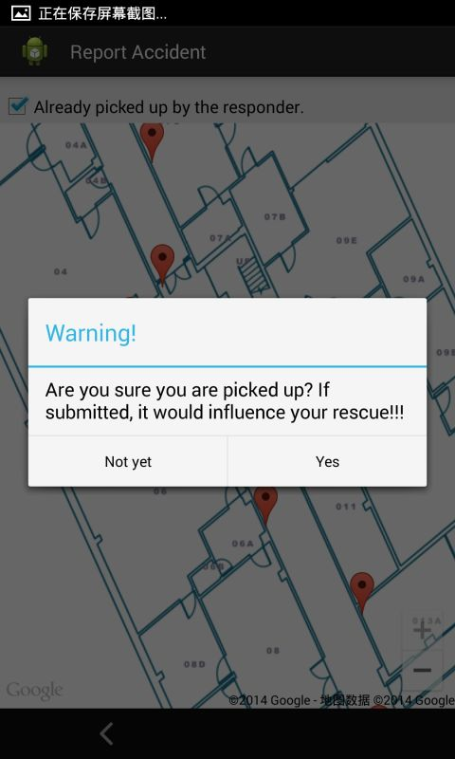

Figure 3 Client-side 2nd activity dialogue Figure 4 Client-side 3nd activity dialogue

**2) Server-side (Responder):** when the user launches the application, he/she can see his/her current location on the screen showing as a blue flag (Figure 5).

As a server, the user can receive any victim’s information including “The number of injures”, “The level of injury”, “The ID of victim”, and “The location of victim”. And after receiving victim’s information, there would be a marker to show this victim’s location and the color of this marker would be different according to the victim’s injury level, namely, there is a “RED” marker added, when the victim is injured seriously; there is a “YELLOW” marker added, when the victim is injured but not very seriously; and there is a “GREEN” marker added, when the victim is not injured (as shown in Figure 5 to figure 7).

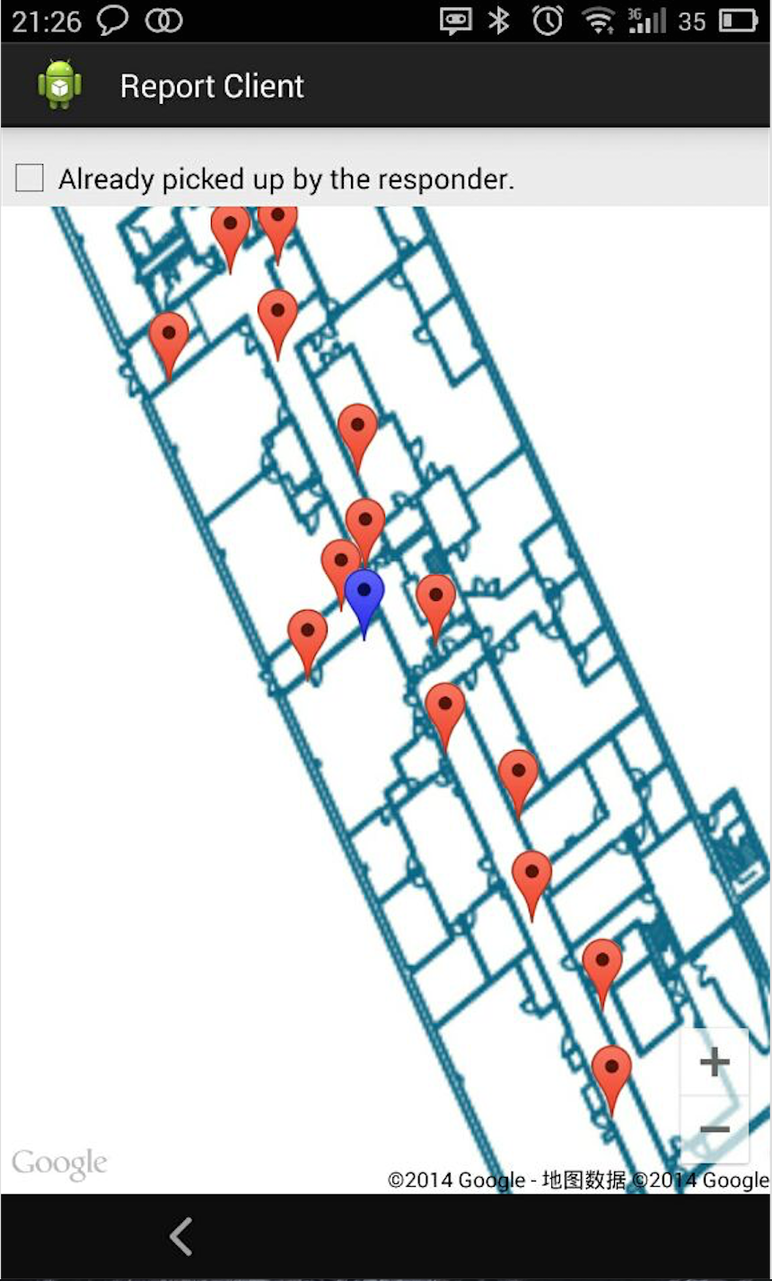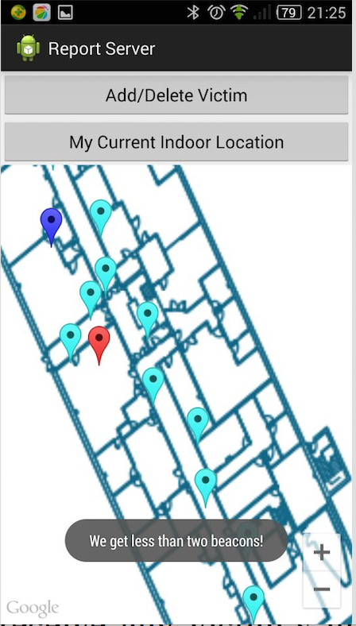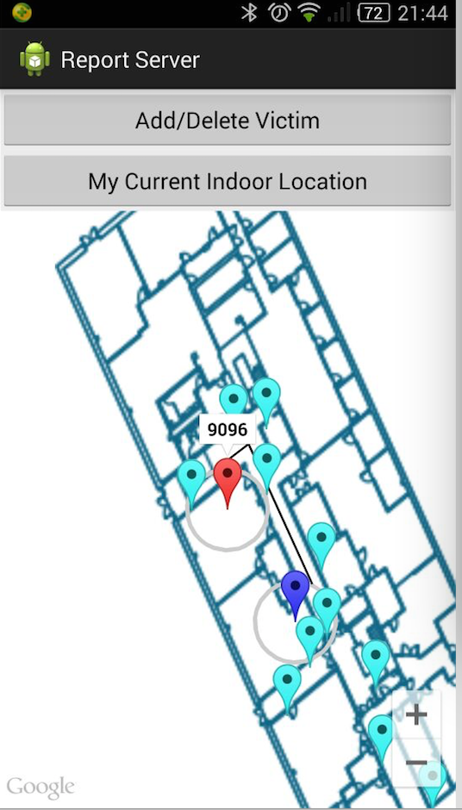Figure 5 Client-side location Figure 6 Server-side received location Figure 7 Shortest path

A circle will be shown on the map centered at user’s location with a radius, which indicates the error range of drawing polyline for routing.

To add a responder’s location manually, click on the map, and then a dialogue will pop out: “Do you want to add your location here?”. If the responder click “YES”, there would be a “BLUE” marker added, and if he/she click “NOT NOW”, it would stay on the previous activity, as shown in figure 8 and 9.

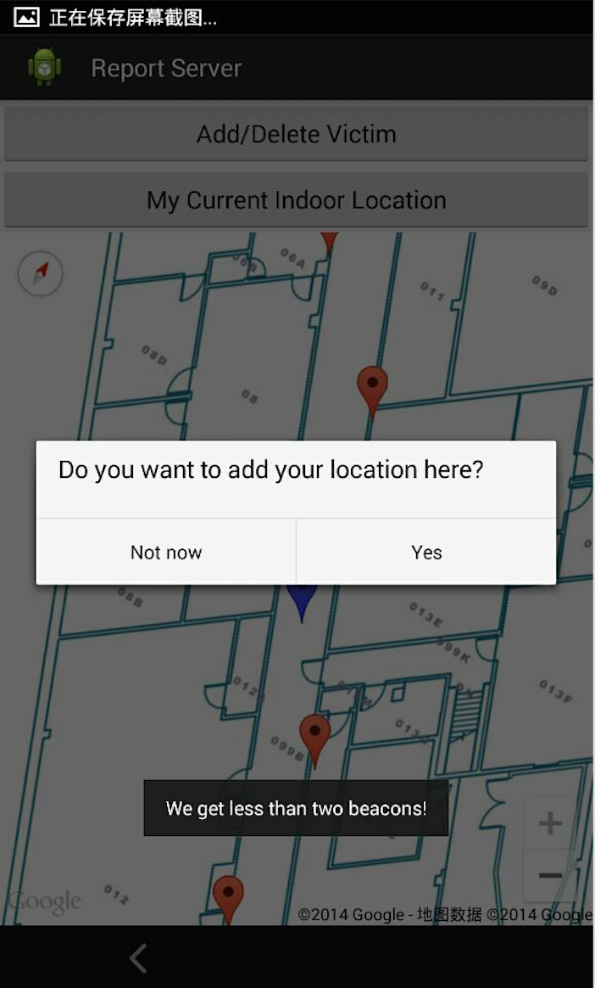 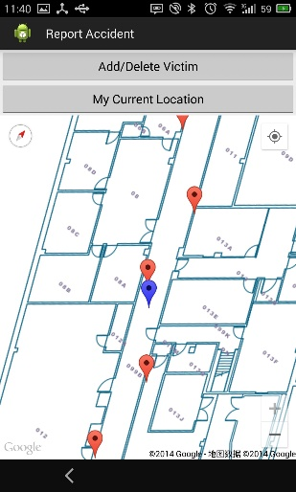

Figure 8 Server-side add-location dialogue Figure 9 Server-side add-location result

After adding the responder’s location, the user can click the marker and the information window would be shown and if he/she clicks on the information window, there would also be a dialogue saying that “Do you want to update your current location?”, if he/she select YES, it would update the responder’s location, as shown in figure 10 and 11.

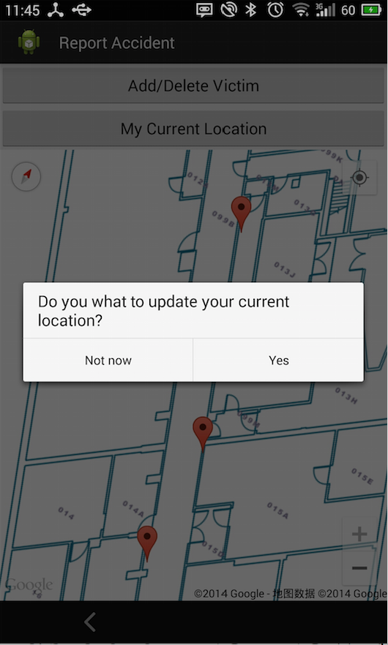 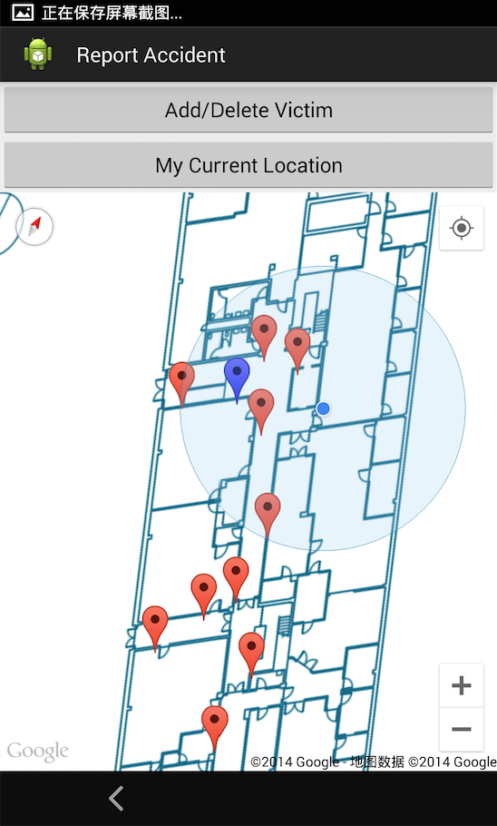

Figure 10 Server-side update-location dialogue Figure 11 Server-side updated location result

To add Victims’ location, long-click on the map, and then a dialogue will pop out: “Do you want to add a victim?”. If the responder click “YES”, there would be a victim marker added, and if he/she click “NOT NOW”, it would stay on the previous activity, as shown in figure 12 to 14.

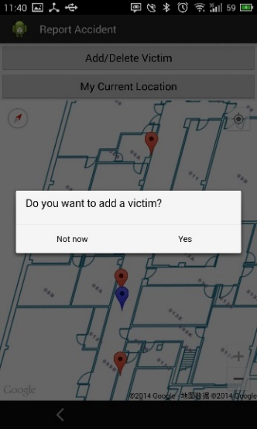 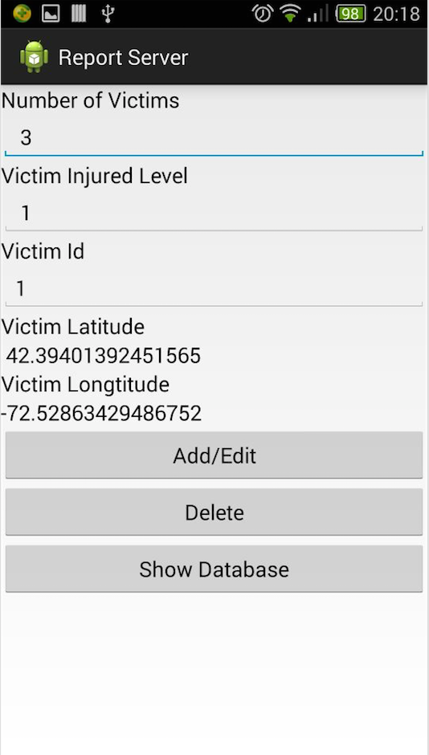 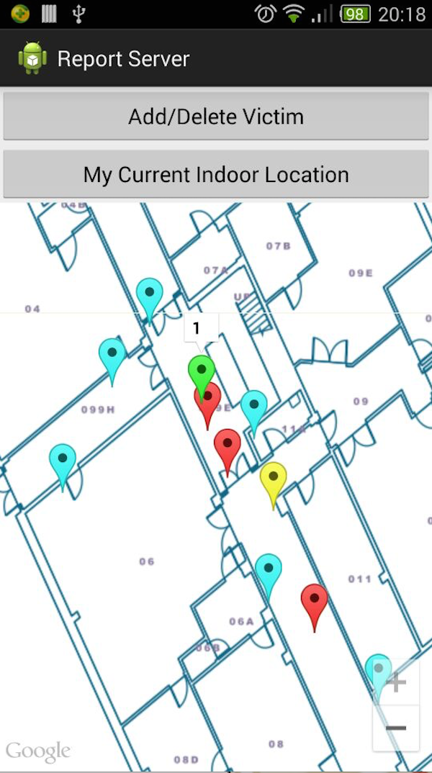

Figure 12 Add victim dialogue Figure13Server-side 2nd activity Figure14 Server-side 1st activity

After adding victim’s location, the user can click the marker and the information window would be shown and if he/she clicks on the information window, there would also be a dialogue saying that “What do you want to do with this victim?” and there are two choices: Edit/Delete Victim and Find This Victim, if the user click on Edit/Delete, the application would go into the second activity and then there are columns for the user to edit the information of victim. After finishing editing or deleting, the application would go back to the previous activity. And if the use clicks Find This Victim, the shortest path to find the victim will be shown. Here are two kinds of different situations to find the victim, as shown in figure 15.

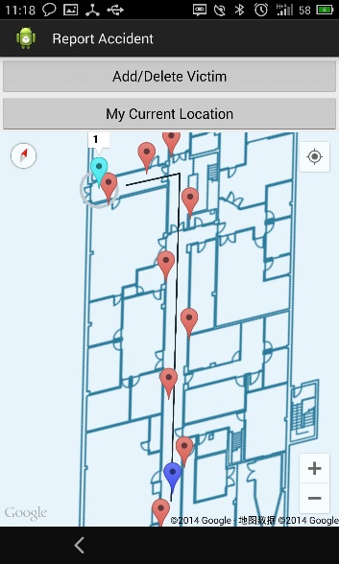 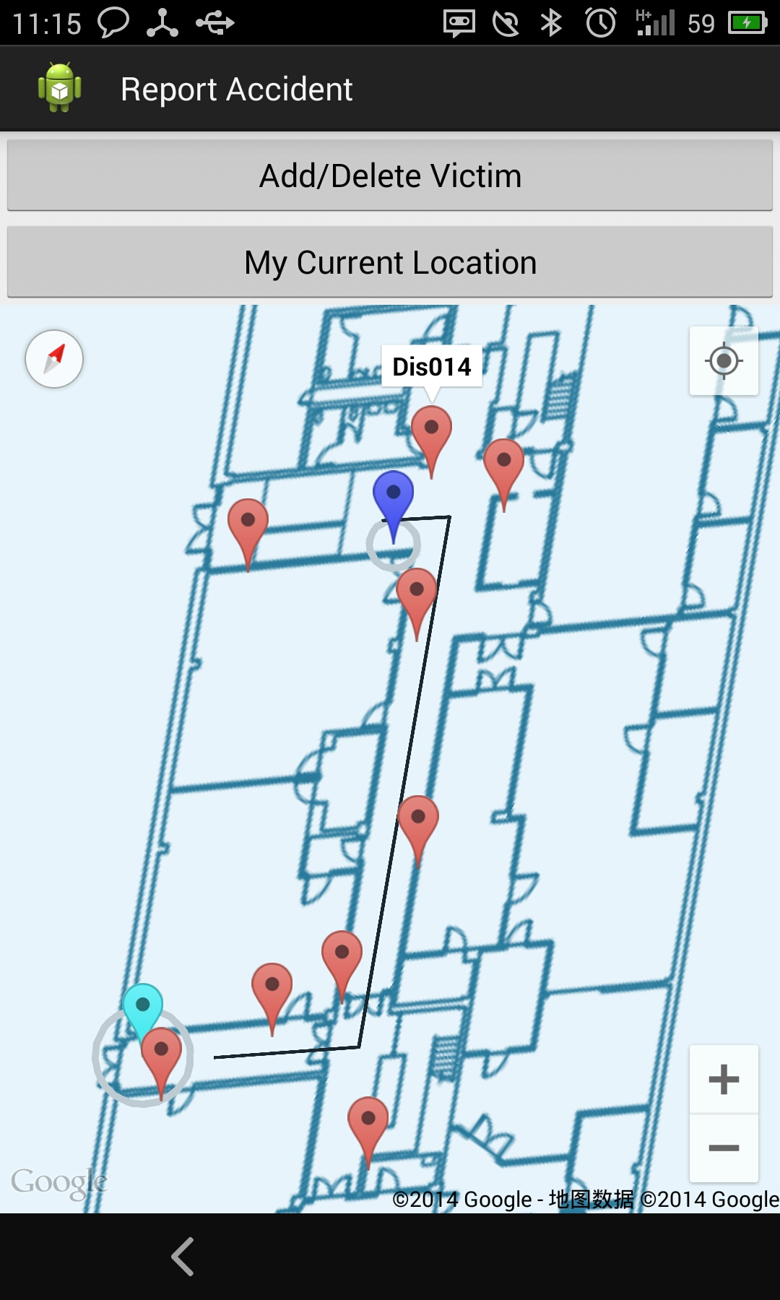

Figure15 Shortest path

If the user clicks some other marker, there will be a warning dialogue as shown in figure 16, and when the user in the 2nd activity select to show all the data in database, there will be the 3rd activity to show all the data in database as shown in figure 17.

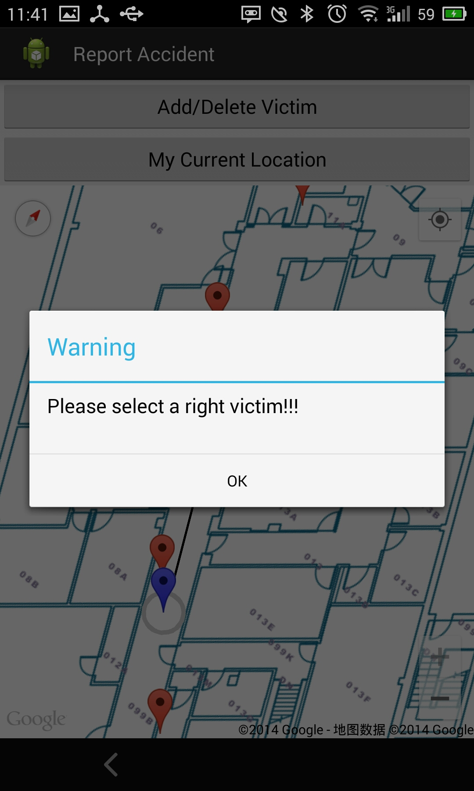 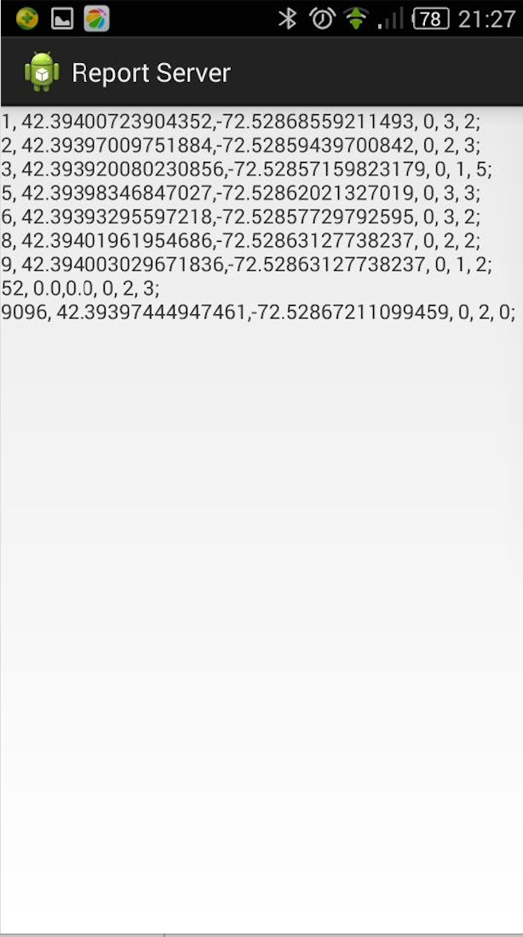

Figure16 Info-window Dialogue Figure17 Server-side Database

As more and more victims report their injury and location information, several green flags show on the map. From server side, responder receives reports from clients. Then under the guidance of Google Map, the responder follows the way the map provides, from the location of responder to Marcus Building, and arrives at the basement of the building depending on rescuing which victims first. Second, when the responder arrives, it follows the route our application provides to rescue victims in a specific place. And then repeat the technique to rescue the rest of the victims.

3**) Outdoor Wayfinding and nearest door :**

When there are many different victims on different location, and when the Report Server was launched, the default mode is that his/her current location would be shown and when he/she clicks the “My current indoor location”, he/she can add his/her location outside the building and click any victim’s information window, and click “Find this victim”, there would be a path to find this victim through different door, actually is the nearest door, as shown in figure 18.

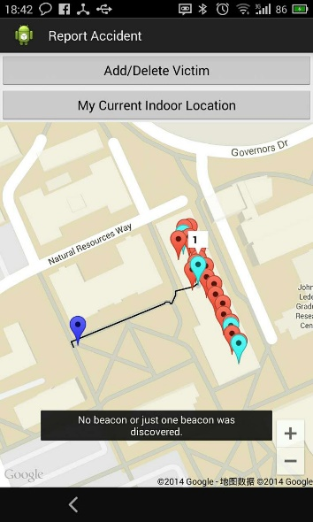 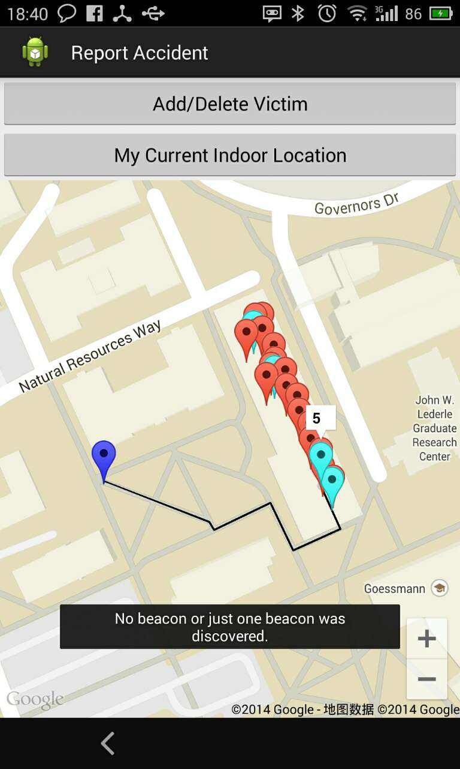

Figure18 Different outdoor and indoor wayfinding